***Practical 5***

Aryaman Gautam

J001

1. Blink SSD - common anode and cathode

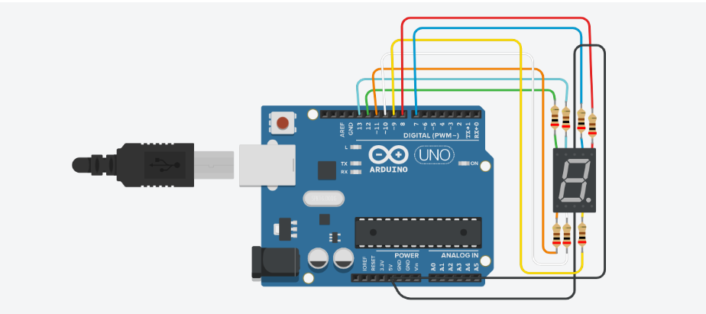

int f = 13;

int g = 12;

int e = 11;

int d = 10;

int c = 9;

int b = 8;

int a = 7;

void setup()

{

pinMode(f, OUTPUT);

pinMode(g, OUTPUT);

pinMode(e, OUTPUT);

pinMode(d, OUTPUT);

pinMode(c, OUTPUT);

pinMode(b, OUTPUT);

pinMode(a, OUTPUT);

}

void loop()

{

digitalWrite(f, HIGH);

digitalWrite(g, HIGH);

digitalWrite(e, HIGH);

digitalWrite(d, HIGH);

digitalWrite(c, HIGH);

digitalWrite(b, HIGH);

digitalWrite(a, HIGH);

delay(1000);

digitalWrite(f, LOW);

digitalWrite(g, LOW);

digitalWrite(e, LOW);

digitalWrite(d, LOW);

digitalWrite(c, LOW);

digitalWrite(b, LOW);

digitalWrite(a, LOW);

delay(1000);

}

1. Build chaser for each LED of SSD- common anode and cathode [ON sequence-1,2,3,OFF sequence-3,2,1]

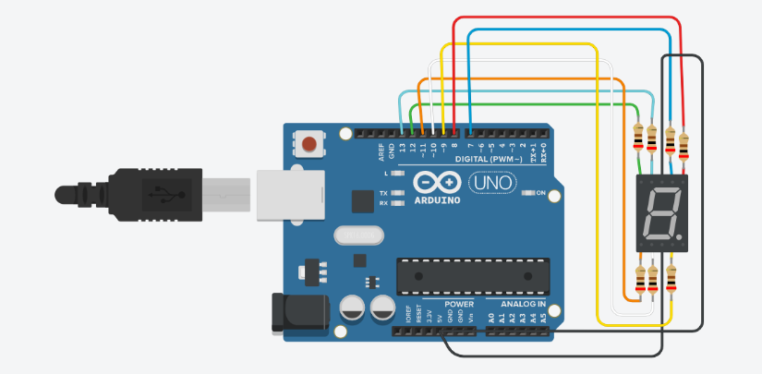

int f = 13;

int g = 12;

int e = 11;

int d = 10;

int c = 9;

int b = 8;

int a = 7;

void setup()

{

for(int i=13; i>=7;i--)

{

pinMode(i,OUTPUT);

}

}

void loop()

{

for(int i=13; i>=7; i--)

{

digitalWrite(i,HIGH);

delay(500);

}

for(int i=7; i<=13; i++)

{

digitalWrite(i,LOW);

delay(500);

}

}

1. Display numbers 0-9 in loop on SSD- common anode and cathode

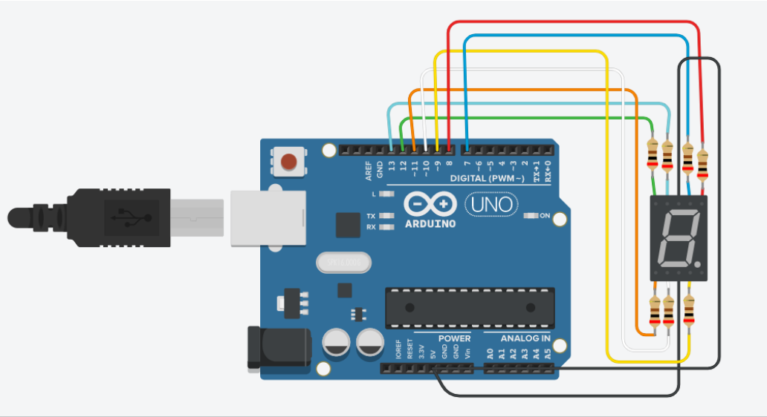

int f = 13;

int g = 12;

int e = 11;

int d = 10;

int c = 9;

int b = 8;

int a = 7;

void setup()

{

pinMode(f, OUTPUT);

pinMode(g, OUTPUT);

pinMode(e, OUTPUT);

pinMode(d, OUTPUT);

pinMode(c, OUTPUT);

pinMode(b, OUTPUT);

pinMode(a, OUTPUT);

}

void zero()

{

digitalWrite(f, 0);

digitalWrite(g, 1);

digitalWrite(e, 0);

digitalWrite(d, 0);

digitalWrite(c, 0);

digitalWrite(b, 0);

digitalWrite(a, 0);

}

void one()

{

digitalWrite(f, 1);

digitalWrite(g, 1);

digitalWrite(e, 1);

digitalWrite(d, 1);

digitalWrite(c, 0);

digitalWrite(b, 0);

digitalWrite(a, 1);

}

void two()

{

digitalWrite(f, 1);

digitalWrite(g, 0);

digitalWrite(e, 0);

digitalWrite(d, 0);

digitalWrite(c, 1);

digitalWrite(b, 0);

digitalWrite(a, 0);

}

void three()

{

digitalWrite(f, 1);

digitalWrite(g, 0);

digitalWrite(e, 1);

digitalWrite(d, 0);

digitalWrite(c, 0);

digitalWrite(b, 0);

digitalWrite(a, 0);

}

void four()

{

digitalWrite(f, 0);

digitalWrite(g, 0);

digitalWrite(e, 1);

digitalWrite(d, 1);

digitalWrite(c, 0);

digitalWrite(b, 0);

digitalWrite(a, 1);

}

void five()

{

digitalWrite(f, 0);

digitalWrite(g, 0);

digitalWrite(e, 1);

digitalWrite(d, 0);

digitalWrite(c, 0);

digitalWrite(b, 1);

digitalWrite(a, 0);

}

void six()

{

digitalWrite(f, 0);

digitalWrite(g, 0);

digitalWrite(e, 0);

digitalWrite(d, 0);

digitalWrite(c, 0);

digitalWrite(b, 1);

digitalWrite(a, 0);

}

void seven()

{

digitalWrite(f, 1);

digitalWrite(g, 1);

digitalWrite(e, 1);

digitalWrite(d, 1);

digitalWrite(c, 0);

digitalWrite(b, 0);

digitalWrite(a, 0);

}

void eight()

{

digitalWrite(f, 0);

digitalWrite(g, 0);

digitalWrite(e, 0);

digitalWrite(d, 0);

digitalWrite(c, 0);

digitalWrite(b, 0);

digitalWrite(a, 0);

}

void nine()

{

digitalWrite(f, 0);

digitalWrite(g, 0);

digitalWrite(e, 1);

digitalWrite(d, 0);

digitalWrite(c, 0);

digitalWrite(b, 0);

digitalWrite(a, 0);

}

void loop()

{

zero();

delay(1000);

one();

delay(1000);

two();

delay(1000);

three();

delay(1000);

four();

delay(1000);

five();

delay(1000);

six();

delay(1000);

seven();

delay(1000);

eight();

delay(1000);

nine();

delay(1000);

}

1. Display A-F in loop on SSD- common anode and cathode

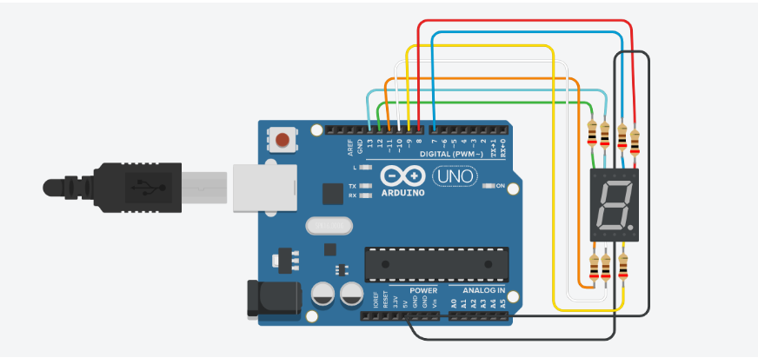

int f = 13;

int g = 12;

int e = 11;

int d = 10;

int c = 9;

int b = 8;

int a = 7;

void setup()

{

pinMode(f, OUTPUT);

pinMode(g, OUTPUT);

pinMode(e, OUTPUT);

pinMode(d, OUTPUT);

pinMode(c, OUTPUT);

pinMode(b, OUTPUT);

pinMode(a, OUTPUT);

}

void print_A()

{

digitalWrite(f, 0);

digitalWrite(g, 0);

digitalWrite(e, 0);

digitalWrite(d, 1);

digitalWrite(c, 0);

digitalWrite(b, 0);

digitalWrite(a, 0);

}

void print_B()

{

digitalWrite(f, 0);

digitalWrite(g, 0);

digitalWrite(e, 0);

digitalWrite(d, 0);

digitalWrite(c, 0);

digitalWrite(b, 0);

digitalWrite(a, 0);

}

void print_C()

{

digitalWrite(f, 0);

digitalWrite(g, 1);

digitalWrite(e, 0);

digitalWrite(d, 0);

digitalWrite(c, 1);

digitalWrite(b, 1);

digitalWrite(a, 0);

}

void print_D()

{

digitalWrite(f, 0);

digitalWrite(g, 1);

digitalWrite(e, 0);

digitalWrite(d, 0);

digitalWrite(c, 0);

digitalWrite(b, 0);

digitalWrite(a, 0);

}

void print_E()

{

digitalWrite(f, 0);

digitalWrite(g, 0);

digitalWrite(e, 0);

digitalWrite(d, 0);

digitalWrite(c, 1);

digitalWrite(b, 1);

digitalWrite(a, 0);

}

void print_F()

{

digitalWrite(f, 0);

digitalWrite(g, 0);

digitalWrite(e, 0);

digitalWrite(d, 1);

digitalWrite(c, 1);

digitalWrite(b, 1);

digitalWrite(a, 0);

}

void loop()

{

print_A();

delay(1000);

print_B();

delay(1000);

print_C();

delay(1000);

print_D();

delay(1000);

print_E();

delay(1000);

print_F();

delay(1000);

}

1. Display reading of potentiometer on SSD (SSD 0 for pot 0-100, 1 for 101-200 ...so on)

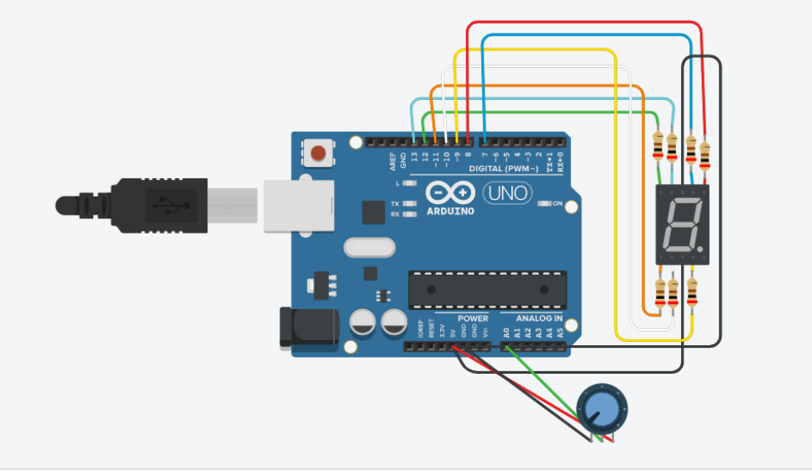

int f = 13;

int g = 12;

int e = 11;

int d = 10;

int c = 9;

int b = 8;

int a = 7;

void setup()

{

pinMode(f, OUTPUT);

pinMode(g, OUTPUT);

pinMode(e, OUTPUT);

pinMode(d, OUTPUT);

pinMode(c, OUTPUT);

pinMode(b, OUTPUT);

pinMode(a, OUTPUT);

pinMode(A0, INPUT);

}

void zero()

{

digitalWrite(f, 0);

digitalWrite(g, 1);

digitalWrite(e, 0);

digitalWrite(d, 0);

digitalWrite(c, 0);

digitalWrite(b, 0);

digitalWrite(a, 0);

}

void one()

{

digitalWrite(f, 1);

digitalWrite(g, 1);

digitalWrite(e, 1);

digitalWrite(d, 1);

digitalWrite(c, 0);

digitalWrite(b, 0);

digitalWrite(a, 1);

}

void two()

{

digitalWrite(f, 1);

digitalWrite(g, 0);

digitalWrite(e, 0);

digitalWrite(d, 0);

digitalWrite(c, 1);

digitalWrite(b, 0);

digitalWrite(a, 0);

}

void three()

{

digitalWrite(f, 1);

digitalWrite(g, 0);

digitalWrite(e, 1);

digitalWrite(d, 0);

digitalWrite(c, 0);

digitalWrite(b, 0);

digitalWrite(a, 0);

}

void four()

{

digitalWrite(f, 0);

digitalWrite(g, 0);

digitalWrite(e, 1);

digitalWrite(d, 1);

digitalWrite(c, 0);

digitalWrite(b, 0);

digitalWrite(a, 1);

}

void five()

{

digitalWrite(f, 0);

digitalWrite(g, 0);

digitalWrite(e, 1);

digitalWrite(d, 0);

digitalWrite(c, 0);

digitalWrite(b, 1);

digitalWrite(a, 0);

}

void six()

{

digitalWrite(f, 0);

digitalWrite(g, 0);

digitalWrite(e, 0);

digitalWrite(d, 0);

digitalWrite(c, 0);

digitalWrite(b, 1);

digitalWrite(a, 0);

}

void seven()

{

digitalWrite(f, 1);

digitalWrite(g, 1);

digitalWrite(e, 1);

digitalWrite(d, 1);

digitalWrite(c, 0);

digitalWrite(b, 0);

digitalWrite(a, 0);

}

void eight()

{

digitalWrite(f, 0);

digitalWrite(g, 0);

digitalWrite(e, 0);

digitalWrite(d, 0);

digitalWrite(c, 0);

digitalWrite(b, 0);

digitalWrite(a, 0);

}

void nine()

{

digitalWrite(f, 0);

digitalWrite(g, 0);

digitalWrite(e, 1);

digitalWrite(d, 0);

digitalWrite(c, 0);

digitalWrite(b, 0);

digitalWrite(a, 0);

}

void loop()

{

int read = analogRead(A0);

if (0<=read && read<=100)

{

zero();

}

else if (101<=read && read<=200)

{

one();

}

else if (201<=read && read<=300)

{

two();

}

else if (301<=read && read<=400)

{

three();

}

else if (401<=read && read<=500)

{

four();

}

else if (501<=read && read<=600)

{

five();

}

else if (601<=read && read<=700)

{

six();

}

else if (701<=read && read<=800)

{

seven();

}

else if (801<=read && read<=900)

{

eight();

}

else if (901<=read && read<=1023)

{

nine();

}

delay(1000);

}

1. If button pressed SSD should have 0 else 1 (do for either common anode or cathode)

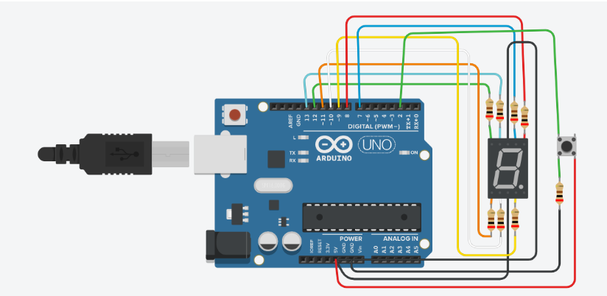

int f = 13;

int g = 12;

int e = 11;

int d = 10;

int c = 9;

int b = 8;

int a = 7;

void setup()

{

pinMode(f, OUTPUT);

pinMode(g, OUTPUT);

pinMode(e, OUTPUT);

pinMode(d, OUTPUT);

pinMode(c, OUTPUT);

pinMode(b, OUTPUT);

pinMode(a, OUTPUT);

pinMode(2, INPUT);

}

void zero()

{

digitalWrite(f, 0);

digitalWrite(g, 1);

digitalWrite(e, 0);

digitalWrite(d, 0);

digitalWrite(c, 0);

digitalWrite(b, 0);

digitalWrite(a, 0);

}

void one()

{

digitalWrite(f, 1);

digitalWrite(g, 1);

digitalWrite(e, 1);

digitalWrite(d, 1);

digitalWrite(c, 0);

digitalWrite(b, 0);

digitalWrite(a, 1);

}

void loop()

{

int reading = digitalRead(2);

if(reading == 0)

{

zero();

}

else

{

one();

}

delay(1000);

}

1. Ring buzzer if tilt is present else stop buzzer

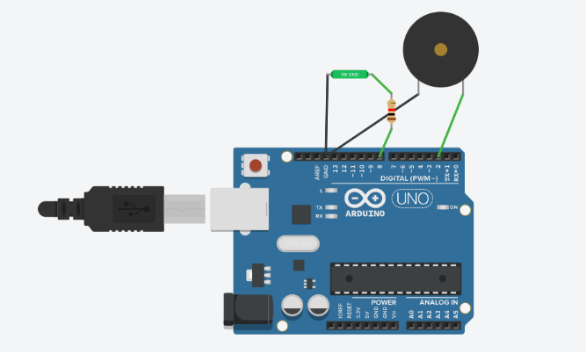

void setup()

{

pinMode(2, OUTPUT);

pinMode(8, INPUT);

}

void loop()

{

int read = analogRead(8);

if(read==0)

noTone(2);

else

tone(2,440);

delay(100);

}

1. Light LED if tilt is present or stop LED

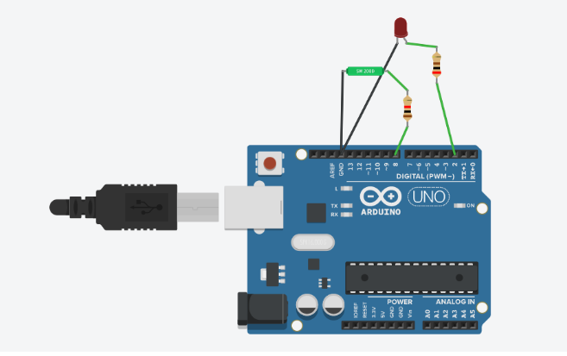

void setup()

{

pinMode(2, OUTPUT);

pinMode(8, INPUT);

Serial.begin(9600);

}

void loop()

{

int read = analogRead(8);

if(read==0)

digitalWrite(2,LOW);

else

digitalWrite(2,HIGH);

delay(100);

}